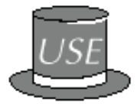
public class Plane
The Plane Queue Program
A Sample Client Program Which Uses the Queue Class

{
public static void main(String[] args)
throws CloneNotSupportedException
{
Queue q = new Queue();
Object e;

q.enqueue("DC9");
q.enqueue("F100");
q.enqueue("F100");
e = q.front();
q.enqueue(e);
q.dequeue();
q.enqueue("MD80");
q.enqueue( q.front() );
q.dequeue();
printQueue(q);
}

private static void printQueue (Queue q)
throws CloneNotSupportedException
{
if (q.isEmpty())
{
System.out.println(
"Your Queue is Currently Empty!");
return;
}

Queue tempQ = (Queue) q.clone();

while (! tempQ.isEmpty())
{
System.out.println(tempQ.front());
tempQ.dequeue();
}
}
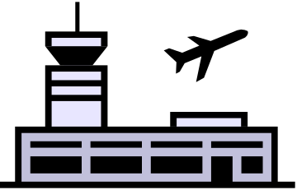}

public class Queue implements QueueInterface {
The Queue Class (with a circular array implementation)

private final int MAX_QUEUE = 50; // maximum size of queue
private Object[] items;
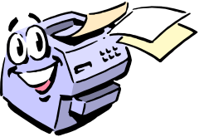 private int front, back, count;

public Queue() {
items = new Object[MAX_QUEUE];
front = 0;
back = MAX_QUEUE-1;
count = 0;
} // end default constructor

public boolean isEmpty() {
return count == 0;
} // end isEmpty

public boolean isFull() {
return count == MAX_QUEUE;
} // end isFull

public void enqueue(Object newItem) {
if (!isFull()) {
back = (back+1) % (MAX_QUEUE);
items[back] = newItem;
++count;
} else {
throw new QueueException("QueueException on enqueue: " + "Queue full");
} // end if
} // end enqueue

public Object dequeue() throws QueueException {
if (!isEmpty()) {
// queue is not empty; remove front
Object queueFront = items[front];
front = (front+1) % (MAX_QUEUE);
--count;
return queueFront;
}
else {
throw new QueueException("QueueException on dequeue: "+ "Queue empty");
} // end if
} // end dequeue

public void dequeueAll() {
items = new Object[MAX_QUEUE];
front = 0;
back = MAX_QUEUE-1;
count = 0;
} // end dequeueAll

public Object front() throws QueueException {
if (!isEmpty()) {
// queue is not empty; retrieve front
return items[front];
} else {
throw new QueueException("Queue exception on front: " + "Queue empty");
} // end if} // end front} // end Queue

